Combating Test Panic
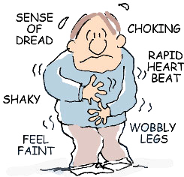

General Advice
- Get a good night's rest.
- Eat breakfast or lunch. This may help calm your nervous stomach and give you energy. Avoid greasy or acidic foods, and avoid overeating. Avoid caffeine pills.
- Nothing reduces stress more than exercise. An hour or two before an examination, stop studying and go workout. Swimming, jogging, cycling, aerobics are great forms of exercising.

Before the Examination
- Allow yourself enough time to get to the test without hurrying.
- Don't swap questions at the door. Hearing anything you don't know may weaken your confidence and send you into a state of anxiety.
- Leave your books at home. Flipping pages at the last minute may only upset you.
- If you must take something, take a brief outline that you know well.

During the Examination
- Take a watch with you, as well as extra pencils, scantron sheets, and blue books.
- Answer the easy questions first. This will relax you and help build your confidence, plus give you some assured points.
- Sit apart from your classmates to reduce being distracted by their movements.
- Don't panic if others are writing and you aren't. Your thinking may be more profitable than their writing.
- Don't be upset if others finish their tests before you do. Use as much time as you are allowed. Students who leave early don't always get the highest grades.
- If you still feel nervous during the test, try this: inhale deeply, close your eyes, hold, than exhale slowly. Repeat as needed.

You can take tests without the nerves!

